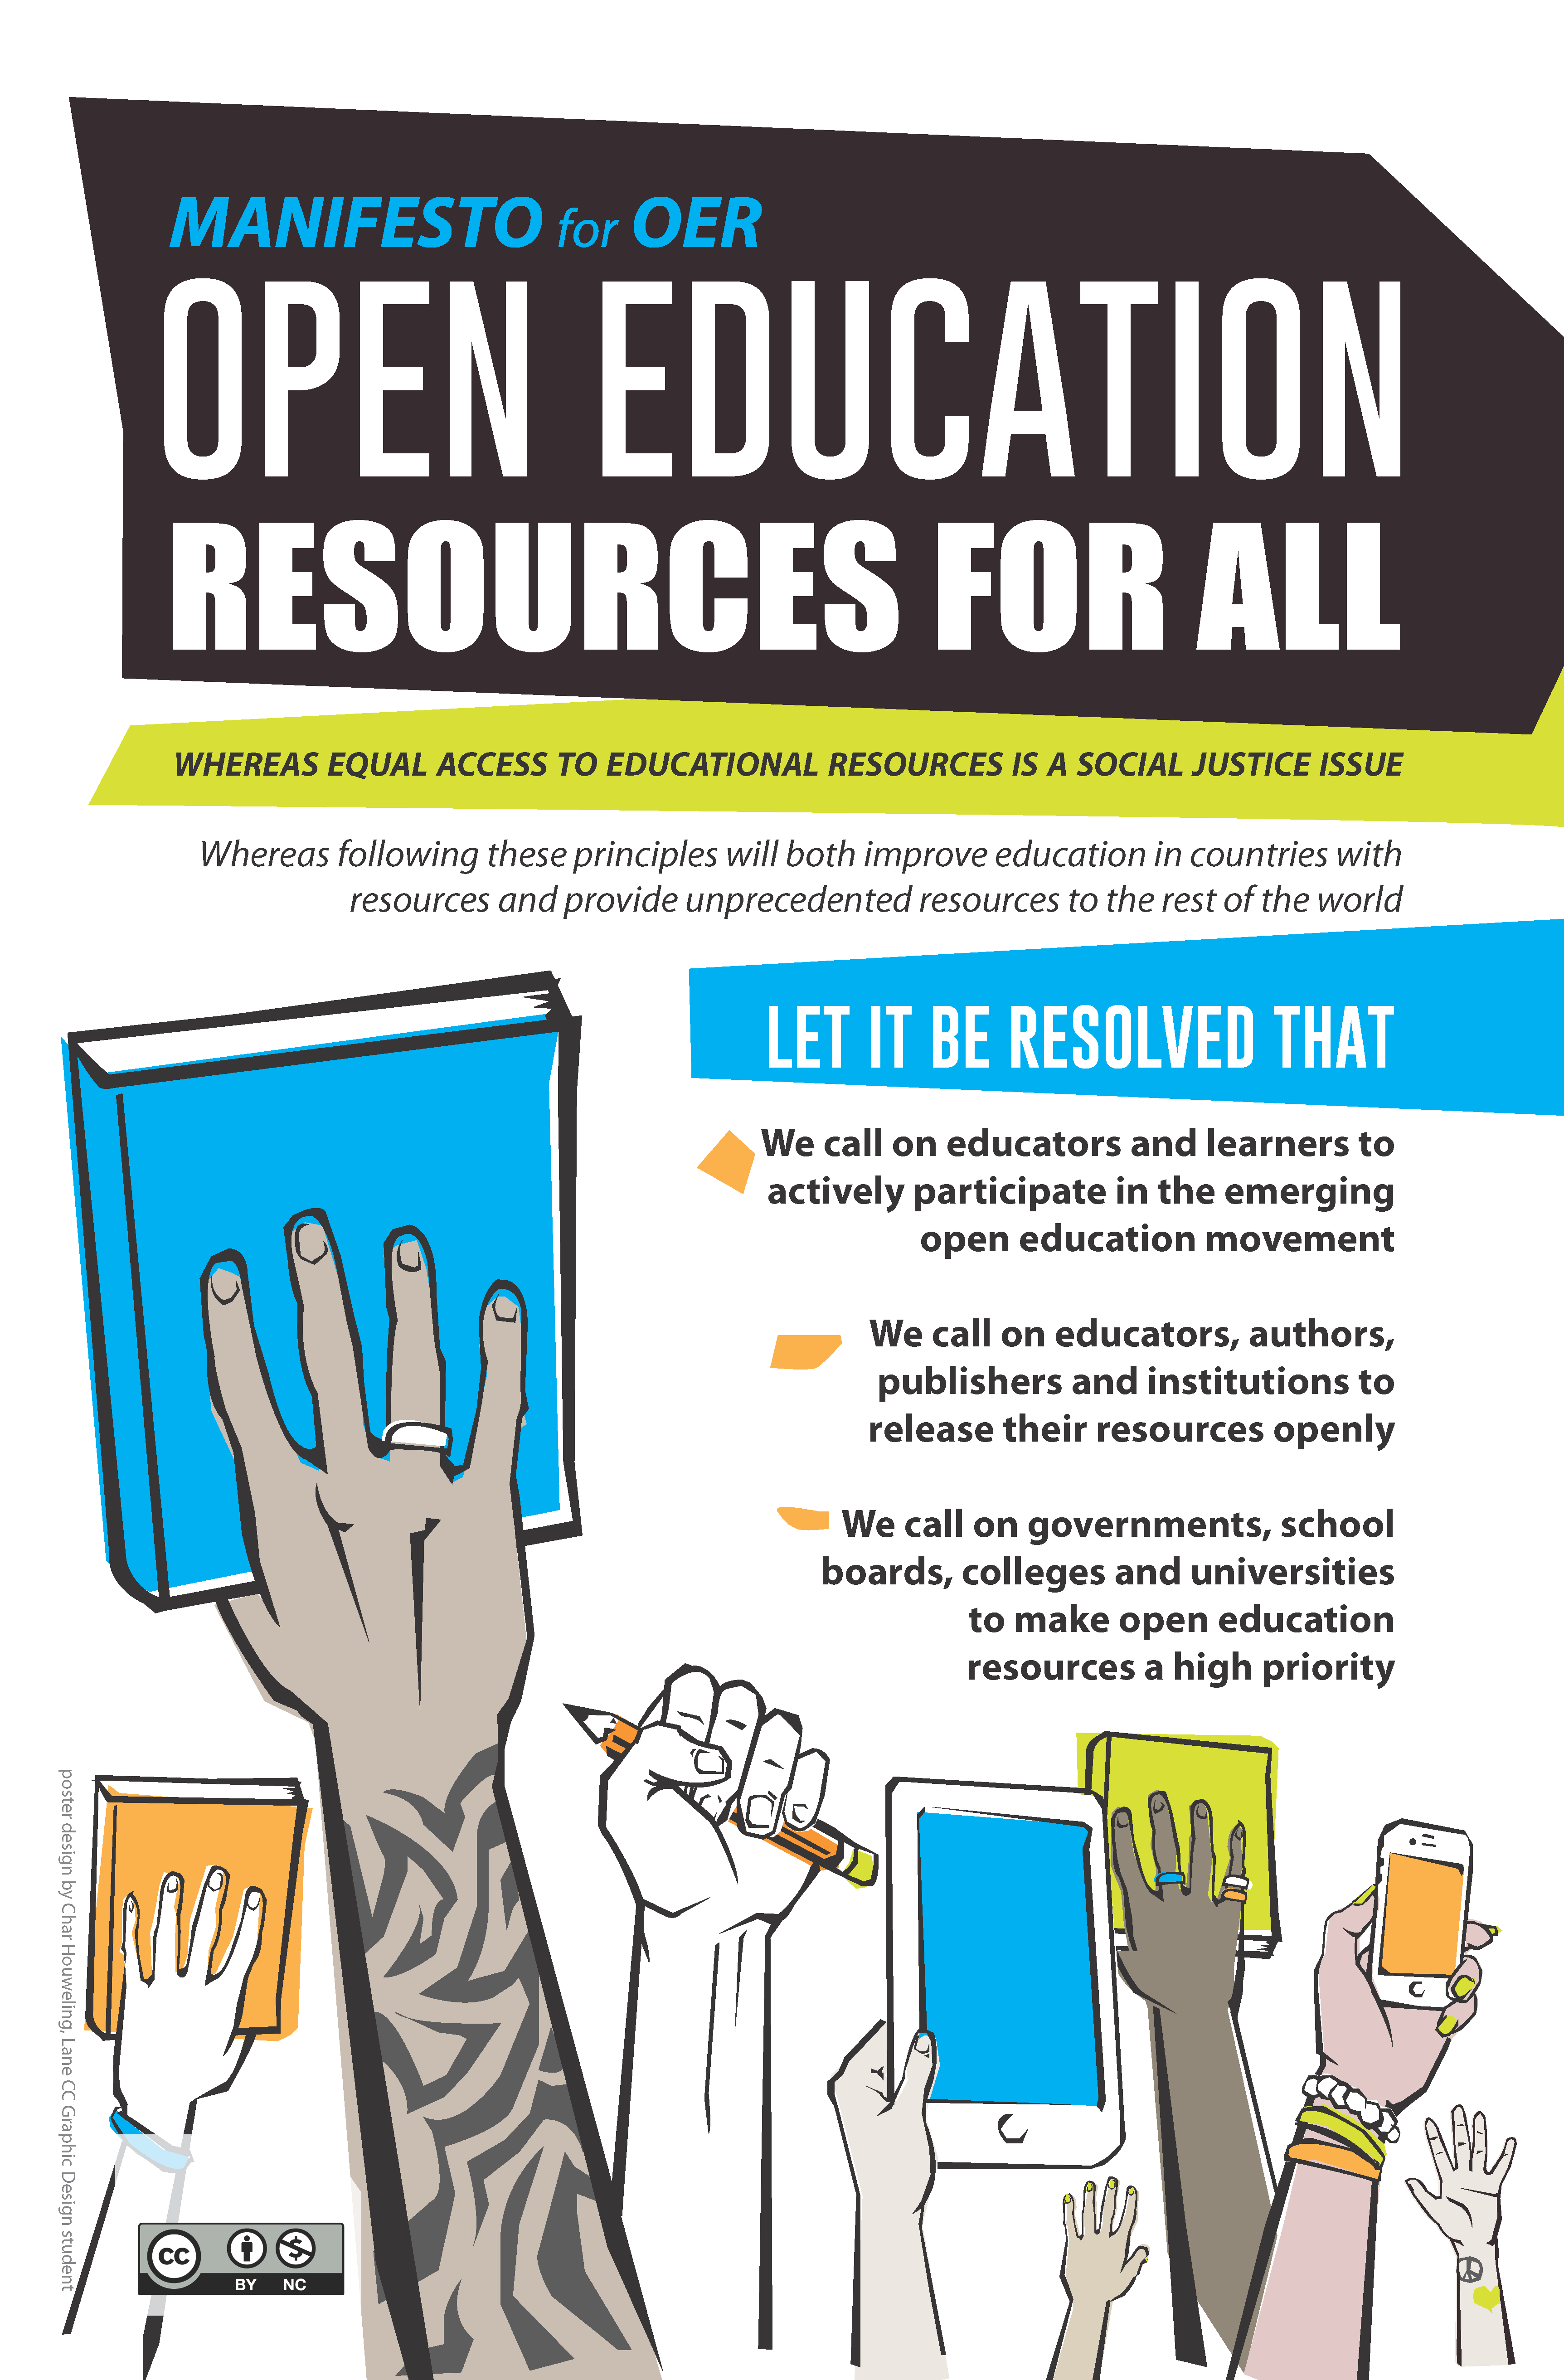

Textbook Affordability Student Toolkit
by Open Oregon Educational Resources
CC-BY 4.0
Table of Contents
Agenda 4
Workshop A (pages 10-11) 4
Workshop B (page 15) 4
Introduction to textbook affordability issues 5
The problem 5
By the numbers 5
The solution: A new model for textbooks 7
Obstacles to open textbooks 7
Who can help, and how? 8
Students 8
Faculty 8
Administrators 8
Librarians 8
Other roles on campus… 8
Campus inventory and goal-setting 9
Open Oregon Educational Resources 9
Fill out a campus inventory to the best of your knowledge. 10
Find a partner and brainstorm achievable, measurable goals that student leadership can adopt for this coming year based on where your campus is right now. 11
What are the gaps between where your college is right now and where you would like to be at the end of the year? What will you need to do to close those gaps? (Whole group) 11
Textbook affordability actions 12
Visibility on campus 12
Social media: #textbookbroke 13
“How Much Did You Pay?” Selfie Table 14
Publicly Thank Faculty Champions 14
Used Book Graveyard 14
“The Price Is Wrong” Game 14
Giant Textbook Prop 14
Open Book Fair 14
Celebrate Open Education Week 14
Panel Discussion 14
Campaign planning 15
Textbook affordability “world café” 15
Practice tough conversations 15
Logistics 15
Commitments 15
Sample scripts 16
Sample tabling script 16
Sample talking points for meeting with a faculty member 17
Sample talking points for meeting with an administrator 18
Sample reporter script 19
Sample faculty thank-you note 20
Sample letter to the editor 21
Open textbook FAQ 22

Agenda

Workshop A (pages 10-11)
Introductions: your name and a memorable experience you’ve had with textbooks. (15 mins)
Examples:
- Taking a class where you didn’t have to buy a book, and what you were able to do with the money instead
- Successfully organizing on campus to help with textbook affordability
- A terrible experience, such as an expensive book that the instructor didn’t use
Amy’s introduction to OER (5 mins)
Fill out campus inventory to the best of your knowledge (15 mins)
Find a partner and brainstorm achievable, measurable goals that student leadership can adopt for this coming year based on where your campus is right now (15 mins)
What are the gaps between where your college is right now and where you would like to be at the end of the year? What will you need to do to close those gaps? (Whole group) (15 mins)

Workshop B (page 15)
Textbook affordability “world café” (45 mins)
Practice tough conversations – avoid demonizing! (15 mins)
Logistics & Commitments (15 mins)
- What is your preferred mode of communication – with students at your college, statewide, and with Open Oregon?
- What can you commit to trying when you get back to campus?
- What do you want to tackle at a statewide level?

Introduction to textbook affordability issues
The high cost of textbooks has become a serious obstacle to affording a college education. The textbook market enables publishers to generate huge profits and engage in bad practices at students’ expense.
Fortunately, we have solutions to this problem, most notably in the form of open textbooks—high-quality books that are available online for free or for a very low cost in print. With solutions like these, we can break the publishers’ stranglehold on the market and help make higher education more accessible to everyone.
These changes won’t happen on their own—students will need to work for them. This toolkit provides resources for student leadership to bring open textbooks to their campuses and save students money.

The problem
Any student who has ever paid $200 for a textbook can vouch that the price of textbooks is out of control.
According to the College Board, the average community college student should budget $1,364 for books and supplies each year. In Oregon, the statewide average materials cost for a 2-year degree is $1,071.
For the many students and families who are already struggling to afford tuition, this out-of-pocket expense can be a huge burden. Many students end up taking on additional loans or credit card debt or working longer hours just to pay for their books. Others compromise their educational experience by opting not to buy books at all, or delay their academic goals.

By the numbers
• The average cost of textbooks for a transfer degree in Oregon now equals 20% of tuition.
• Textbook prices rose 82% between 2002 and 2012, about three times the rate of inflation.
• 65% of students report having skipped out on buying or renting a textbook due to cost.
• 14% of students report they occasionally or frequently drop a course due to the textbook cost.
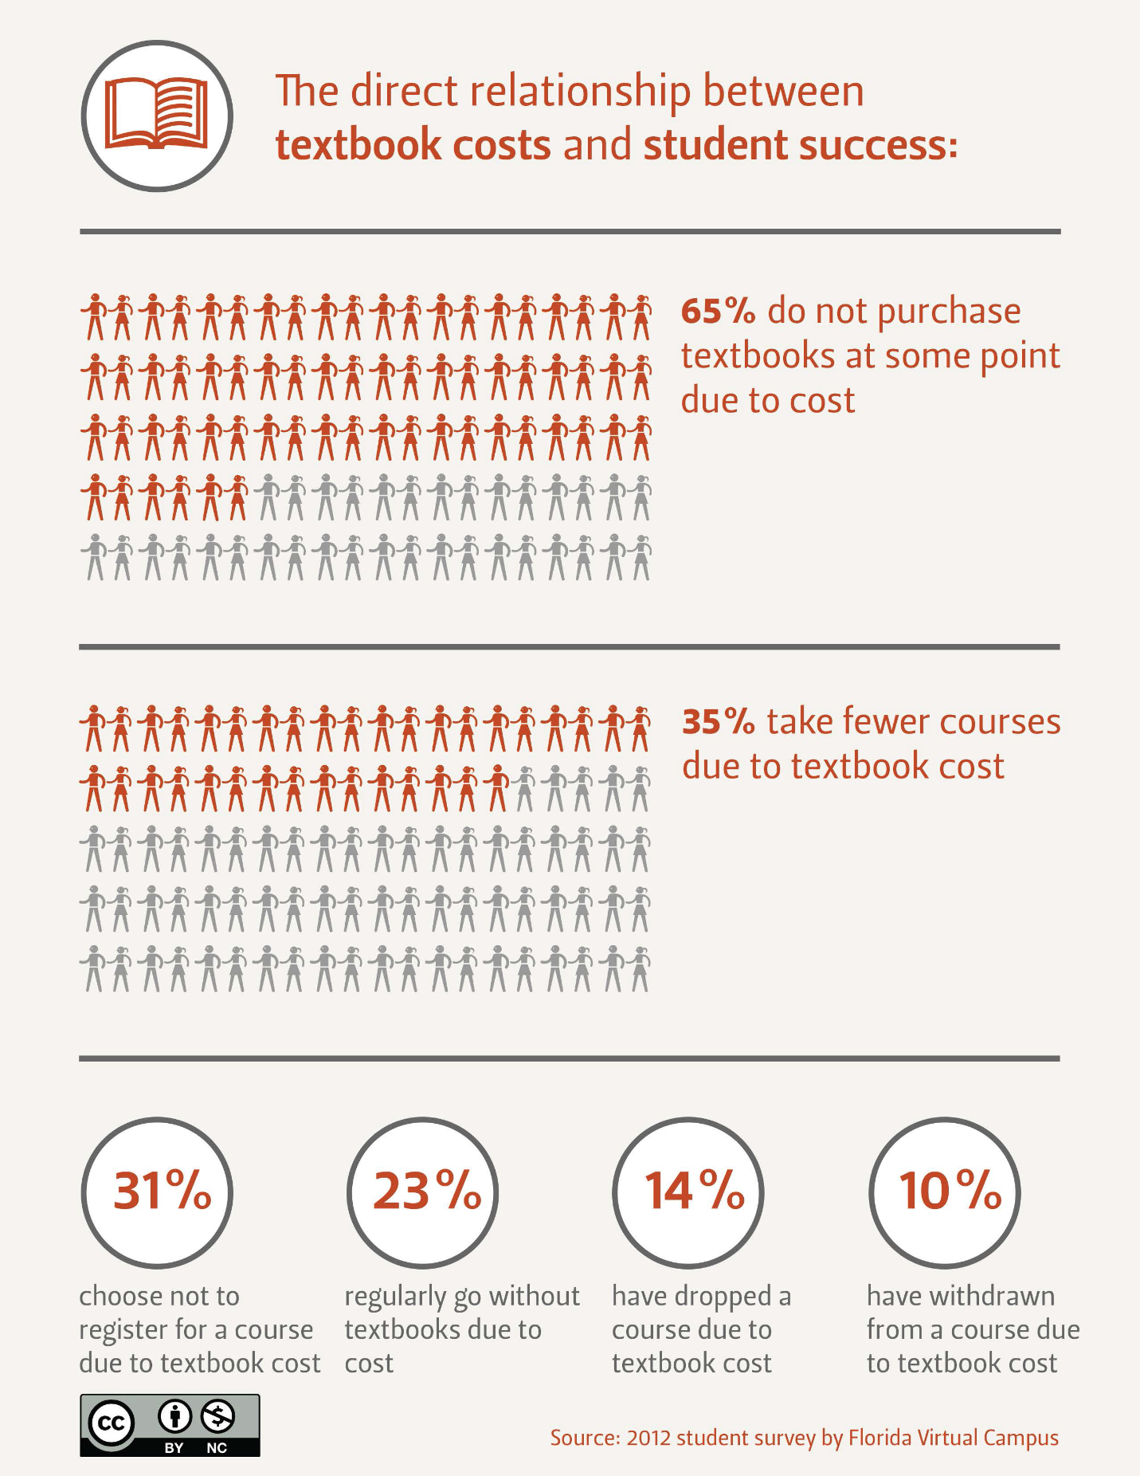
"The direct relationship between textbook costs and student success" by Oregon State University is licensed under CC BY-NC 4.0.

The solution: A new model for textbooks

A new model for educational materials has emerged: open educational resources (OER), which use today’s technology to make textbooks and other learning materials free and shareable. These materials are open because they are either in the public domain or carry an open copyright license that permits their free reuse or repurposing by others.
There are many types of OER, including full courses, lesson plans, videos, and exams, but the form of OER that is most visible is the open textbook. This alternative to traditional textbooks has the power to drive down textbook prices for good.
Here’s how open textbooks work:
• Open textbooks are available for free to read online or download.
• Open textbooks can be printed at low cost, typically $20-40.
• Many open textbooks are written and reviewed by experts, and studies have found that students do as well or better in classes that use open textbooks.
• Open licenses allow instructors to adapt the textbook and customize it to fit their course.
• Electronic versions of open textbooks never expire so you can keep your copy forever.
Open textbooks are already available for hundreds of courses and are in use in over 150 courses at Oregon community colleges. You can find out which courses have adopted open textbooks at http://openoregon.org/resources/.
The savings from using open textbooks can be huge. Getting a single math or science class to switch to an open textbook can save students tens of thousands of dollars. The math is clear: if a class of 100 students saves $100 each, that’s $10,000 in savings.
Open textbooks address the intrinsic flaws in the traditional textbook market, while also promoting a new system where knowledge is shared and free to all.

Obstacles to open textbooks
Open textbooks face three big challenges:
• It takes time and money to create open textbooks.
• It takes time and resources to introduce faculty to open textbooks and their benefits.
• It takes time and training to support faculty in using open textbooks.
To overcome these challenges, we need startup investment—from colleges, foundations, and government—to create and promote open textbooks. It doesn’t take a lot of money to get the ball rolling, but the payoff is tremendous. Money spent to create and promote open textbooks ends up saving students many times the amount of the initial investment.
Student groups can take action to help overcome these obstacles.

Who can help, and how?

Students
- Raise awareness about solutions to the problem
- Gather and share data on textbook costs, student preferences, and personal impact of prices
- Advocate for initiatives that offer faculty time/money to redesign their courses around lower-cost resources
- Adopt a student government resolution committing to specific actions
- Campaign for a vote on allocating student fee money for OER support
- Put an open license on all content that your group creates
- Publicly thank faculty who adopt open textbooks
- Model a positive and respectful tone – avoid demonizing!

Faculty
- Learn about options to lower textbook costs for students; adopt an open textbook if appropriate
- Support student activism around textbook affordability
- Work with faculty leadership and administrators to make textbook affordability a priority on campus

Administrators
- Create policies, resolutions, strategic priorities to address textbook affordability
- Offer faculty incentives of time/money to lower textbook costs for students
- Collaborate with bookstore managers to mitigate impact of lost textbook revenue

Librarians
- Find open textbooks and other open content (chapters, videos, images, ancillaries, etc)
- Advise on copyright and open license questions
- Recommend ebooks and multimedia from the library’s digital collection (these are not open, but are already paid for through student tuition and fees)

Other roles on campus…
- Instructional designers help faculty create online and hybrid courses
- Accessibility staff ensure that courses and content are accessible to all learners
- Bookstore managers stock printed copies of open textbooks

Campus inventory and goal-setting
When starting any new initiative as a student group, it is important to recognize that there are likely already faculty, staff, or librarians on your campus who care about an issue as much as you do. Before starting to work on an OER campaign in isolation, an indispensable first step is to conduct a scan of the advocates and resources that already exist at your institution. This could include:
- Faculty who engage in open educational practices in their courses
- Staff at teaching and learning centers who offer resources and professional development for faculty who wish to adopt open educational practices
- Librarians who encourage faculty to adopt open resources in place of traditional ones;
- Administrators who are interested in making open education part of your college’s strategic goals

If you already know one or more such people, ask about the work they are doing, and ask them to connect you with other advocates. If you don’t know where to start, reach out to the broader OER network beyond your institution, as you might discover new connections.

Open Oregon Educational Resources
Openoregon.org is a good place to find out what is happing at your college and across the state.
- The Open Oregon Resources page (http://openoregon.org/resources/) is a list of all known adoptions at Oregon community colleges. Use the search box to filter for your college.
- The Interactive Z-Degree graphic (http://openoregon.org/z-degree/) shows how close we are to having a zero textbook cost transfer degree – statewide or for individual colleges. Use the drop-down menu to filter for your college.
- Campus reports (http://openoregon.org/category/campus-report/) offer narrative snapshots of OER work at the time.
- What is the cost of course materials for a transfer degree at each community college in Oregon? (http://openoregon.org/what-is-the-cost-of-course-materials-for-a-transfer-degree-at-each-community-college-in-oregon/) is a detailed report on locally relevant research for each college. Click on the graph thumbnails for data on each college.

Fill out a campus inventory to the best of your knowledge.

People (ex: faculty champions, bookstore manager, etc) | Resources (ex: dedicated student fees, previously collected data, etc) | Initiatives (OER steering committee, faculty grant program, etc)

Find a partner and brainstorm achievable, measurable goals that student leadership can adopt for this coming year based on where your campus is right now.
Goal wording: Get [target] to do [proposal] by [timeframe].

What are the gaps between where your college is right now and where you would like to be at the end of the year? What will you need to do to close those gaps? (Whole group)

Textbook affordability actions
Before you take any action in your campaign, make sure that you know and follow campus rules as they apply to the activity you are going to do.

Visibility on campus
Visibility is one of the most effective ways to educate students, faculty, and other audiences about your campaign and build awareness about open textbooks. When done well, this visibility can help your campaign succeed while also improving the name recognition and reputation of your student government.
Examples of on-campus visibility tactics:
- Create a clear, simple, memorable slogan for your campaign
- Distribute leaflets/flyers on campus
- Hang posters
- Chalk messages on sidewalks
- Put table tents on tables in dining halls, library, computer lab, etc.
- Ask the bookstore to insert a flyer in every bag
- “Tabling” – set up a table and talk to people who walk past
- Make an interactive poster that encourages students to participate
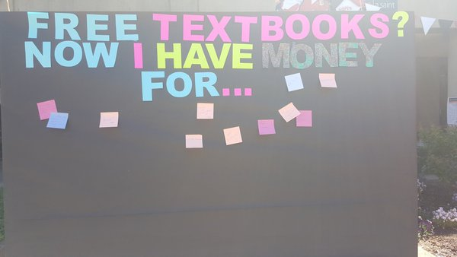
Interactive post-it poster at Mt Hood Community College OER Festival by Jaime Wood, CC-BY 4.0.

Social media: #textbookbroke
Facebook, Twitter, Instagram, and other social media sites are great ways to spread ideas and recruit your friends to support the campaign.
Add a social media component to every piece of your campaign. Make sure your volunteers post about every campaign event they attend—especially if they can post photos or videos.
Students have been using the hashtag #textbookbroke to draw attention to rising textbook prices and the need to adopt open textbooks. This hashtag has already shown up on social media sites several million times, catching the attention of campus administrators, legislators, and the media.
As you run your campaign, add #textbookbroke to your posts to add your voice to this national movement. You can incorporate the name of your school, for example #textbookbrokePCC.
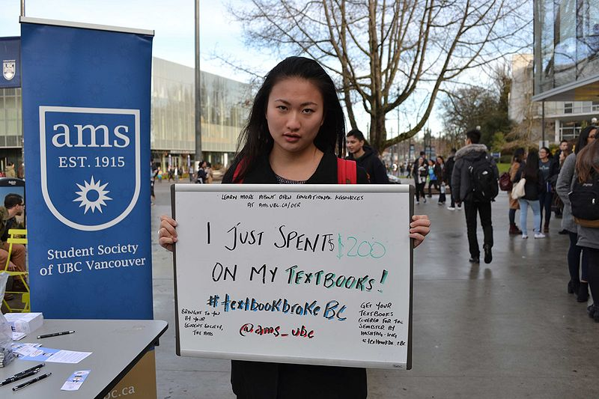
AMS textbookbrokeBC by Daniel Munro. CC-BY-SA 3.0.
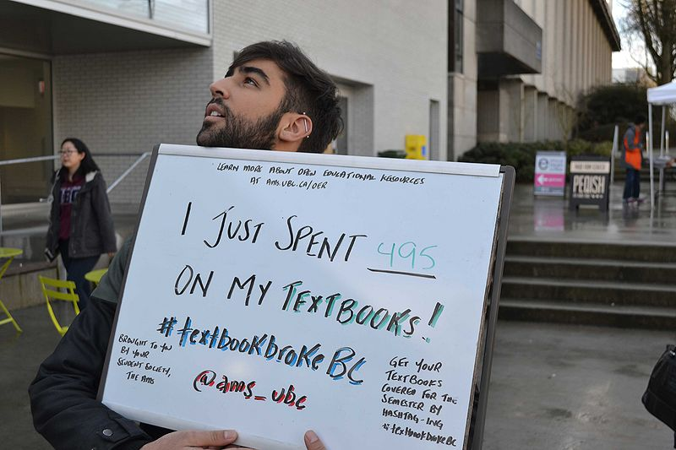
AMS textbookbrokeBC by Daniel Munro. CC-BY-SA 3.0.
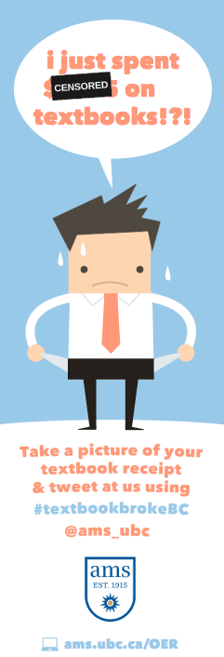
TextbookbrokeBC Bookmark by AMS UBC. CC BY 4.0.

“How Much Did You Pay?” Selfie Table
Hold this event at the beginning of the term. Have a dry-erase board or sticky notes and ask students to write down the amount of money they spent that term on textbooks. Then take a picture of them holding the dry-erase board and post their photo with the hashtag #textbookbroke.

Publicly Thank Faculty Champions
Show faculty that you appreciate the time and effort it took to redesign their course around open or low-cost materials. Write thank-you notes, hold a public recognition ceremony, or hang a poster on their office door that was signed by all their students. Make sure that other colleagues and administrators know how you feel about the faculty that adopt open textbooks!

Used Book Graveyard
You can illustrate the impact that unnecessary new editions have on the used book market by setting up a graveyard on the quad for all of the used books that can’t be sold back. Make gravestone shapes out of cardboard and paint them with the titles of popular used textbooks. You can also add creative epitaphs like, “Here lies the 4th Edition, which died before its time.”

“The Price Is Wrong” Game
Ask students to stop and play this variation on “The Price Is Right.” Put textbooks on display and ask students to guess how much each one costs. Give out prizes and campaign leaflets to the students who play. The sad thing is that everyone loses—even if they guess the right price, the price is still wrong.

Giant Textbook Prop
A tried-and-true way of getting attention on campus is to build something big. Use cardboard, paper mache, or other materials to build a giant textbook that you can set up around campus. Make an absurdly high price tag and other features that mock publisher practices that drive up the cost of books.

Open Book Fair
Organize an “Open Book Fair” to showcase open textbooks. As with a normal book fair, set up showcase tables, including sample copies of open books and posters comparing textbook prices between open textbooks and their traditional counterparts.

Celebrate Open Education Week
Each year during this week in March, people around the world celebrate open textbooks and open educational practices. Organize an event on your campus – any idea here would be great, or create your own! Register and check for nearby events at www.openeducationweek.org.

Panel Discussion
Organize a panel or roundtable discussion representing various perspectives about textbook affordability on campus. Key people to include: a professor, a student, the bookstore, and a librarian.

Campaign planning

Textbook affordability “world café”
The different tables around the room are set up for different textbook affordability actions that you can take on your campus. The “wildcard” table is where you can make up your own textbook affordability action.
Spend 8-10 minutes at each table brainstorming how this action could work on your campus: how would it help you achieve your specific goal? What sort of planning would be required? What kind of publicity could you generate? What would be a logical next step after doing this action? When time is up, move to a different table.

Practice tough conversations
Find a partner and practice having a conversation with: another student, a faculty member, and an administrator. Avoid demonizing! This is not about blaming people, it’s about students.
In effective conversations you will:
- Listen as much as you talk. Other people care about this issue too, and they often are already implementing solutions of their own. Make sure you ask about what they think and use it to make your pitch stronger.
- Always go into the conversation with a plan for your “ask” — i.e. what you are going to ask the person to do. Consider what resources the person has, what their interests are, and what would be most helpful to the campaign. For example, for the Faculty Senate president, your top ask might be for them to send an all-faculty email. Secondary asks might be to let you come speak at a meeting or post a link on their website.
- Have a follow-up plan. If the person says “yes” to something, make sure to make a specific plan to follow up about it, including a specific time and who will contact whom. For example, if a professor says they’ll post a link, you might say you’ll send them an e-mail with the link when you get back and will stop by again in two weeks to see what the response has been.

Logistics
It’s a unique opportunity to have student government representatives from all over the state in the same room. How do you want to communicate with each other? How do you want to communicate with Open Oregon Educational Resources? Are there any resources or issues we can work on at the statewide level?

Commitments
We need to know what’s happening across the state so that we can track each other’s progress, celebrate success, and reach out when we need help. We’ll wrap up the day by recording commitments for the coming year in a shared doc: http://bit.ly/2cpx2cB.

Sample scripts

Sample tabling script
Hi, can you help make textbooks more affordable?
My name is _________ and I’m with __________. Nice to meet you!
Textbooks are way too expensive. We’re letting the administration and faculty know that book prices are out of control. Can you help us out by showing them how much you spent on textbooks this semester?
[Hand over the dry-erase board.]
Great! Just write on here the amount you spent on books this semester, then we’ll shoot a photo of you holding the board. We’ll post the photo online and send it to the administration.
[Take the picture.]
Thanks! To make textbooks more affordable, we’re urging the school to start using open textbooks. These are just like regular textbooks, except that the authors have decided to give the books away for free. Would you [student action here] in support of open textbooks?
[Hand over the clipboard with student action info.]
Thanks! Here’s a leaflet with tips on how to save money on textbooks!
*Tips for tablers:
- Smile, make eye contact, and wave—it makes a huge difference.
- Speak loudly, slowly and clearly.
- Hand over the dry-erase board and clipboard as quickly as possible.

Sample talking points for meeting with a faculty member
Intro: Hi, Professor. I’m [Name] from [Student Group]. Thank you for letting me come talk to you about our campaign to make textbooks affordable.
Introduce the problem: Textbook costs are a big issue for students here on campus. Textbooks are expensive—$1200 per student per year for books and supplies, and prices have been rising at three times the rate of inflation. Students are even opting not to buy the books—65 percent of students surveyed reported not buying or renting a required book because of the price. [If relevant, tell a brief personal story about how textbook costs have affected you.]
Ask: Is this a problem that’s come to your attention before?
Introduce the solution: The good news is that affordable alternatives exist that can save students a lot of money. Open textbooks are books that are published under an open license that allows them to be used and shared for free. Open textbooks are comparable to traditional textbooks: they are written and reviewed by experts and cover the standard material for a course. Open textbooks have benefits that make them preferable to traditional textbooks because instructors can adapt the text by adding their own content or problem sets or removing unwanted material.
Ask: Have you come across open textbooks before?
Call to action: Open textbooks are a great solution, but the challenge is that not enough professors have the support they need to use them. I wanted to discuss a couple ways you might be able to help.
Sample ask: Would you be willing to talk with a librarian about using open textbooks in your classes?
Sample ask: Would you be willing to share information about open textbooks with your colleagues?
Sample ask: Would you be willing to support our campaign to expand the use of open textbooks?
Closing: Thank you for agreeing to [Action]. I will email you in a couple weeks to follow up and see how it went.

Sample talking points for meeting with an administrator
Intro: Good morning, I’m [Name] from [Student Group]. Thank you for letting me come talk to you about our campaign to make textbooks affordable.
Introduce the problem: Textbook costs are a big issue for students here on campus. Textbooks are expensive—$1200 per student per year for books and supplies, and prices have been rising at three times the rate of inflation. This problem has an enrollment impact—35 percent of students surveyed take fewer courses because of cost, while 14 percent have dropped a course and 10 percent have withdrawn because of cost. [If relevant, tell a brief personal story about how textbook costs have affected you.]
Ask: Is this a problem that’s come to your attention before?
Introduce the solution: The good news is that affordable alternatives exist that can save students a lot of money. Open textbooks are books that are published under an open license that allows them to be used and shared for free. Research suggests that students will have better course outcomes, stay in their courses, and be able to progress more quickly to a degree without the huge burden of textbook costs.
Ask: Do you see textbook affordability fitting in with the college’s strategic priorities for the year?
Call to action: Open textbooks are a great solution, and we have support for their use on campus, but the challenge is that not enough professors have the support they need to use them. I wanted to discuss a couple ways you might be able to help.
Ask: Would you be willing to sponsor a workshop to raise faculty awareness of open textbooks?
Ask: Would you be willing to fund a grant program to offer faculty time and resources to adopt open textbooks?
Ask: Would you be willing to hire a staff person to work directly with faculty to expand the use of open textbooks?
Ask: Would you be willing to set a big hairy goal for a zero textbook cost degree program at our school?
Closing: Thank you for agreeing to [Action]. I will email you in a couple weeks to follow up and see how it went.

Sample reporter script
Start here if you are starting with the newsroom:
Hi, this is [your name] from [your organization’s] affordable textbooks campaign at [your college]. I just sent an advisory about an event on college textbook costs coming up on [date]. Did you receive it?
[Sometimes they will ask for the subject of your e-mail so they can find it, so have that on hand. If they did not receive it, ask for the correct e-mail address and call back once you send it.]
Great. The cost of textbooks is becoming very significant issues for students and parents, and the event will showcase some of the up-and-coming solutions. Who would you recommend I talk to about covering it?
Start here once you get to a reporter:
Hi, this is [your name] from [your organization’s] affordable textbooks campaign at [your college]. I’m calling to let you know about a potential story on the high cost of textbooks, and an event coming up at [your college] on [date]. Do you have a moment?
Thanks! As you probably know, the cost of college textbooks is a serious issue for students and parents – prices are rising more than 4 times inflation and a lot of books cost more than $200 each.
I wanted to let you know that [your organization] is holding an event at [your college] on [date] to showcase open textbooks that are free online. At the event we'll have [insert 1-sentence description of event].
Is this something you would be interested in covering? Great! Again, the event will be on [date] at [time] in [location]. We're planning to kick it off with a press conference where we'll have [list of speakers].
I’ll send you a media advisory so you have all of the details. What is the best email address to send it to?
Thank you for your time!
*Tips for calling reporters:
- Always ask reporters if they have a minute to talk in case they are on deadline.
- Tell them enough about the story to entice them, but don’t give it all away.
- Send them an email after the call with more information.
- Always follow up to remind them of the event closer to the date.

Sample faculty thank-you note
Dear Professor [last name]
Thank you so much for using an open textbook in [fill in course]. This book allowed me to save [approximately how much you saved] dollars! With the money I saved, I can [information about how this has helped you, what you will be able to do with the savings, impact on your ability to complete your studies].
Thanks again for increasing access to education in your class. It makes a huge difference for me!
[sign your name here]

Sample letter to the editor
[Insert short reference to article you are responding to. For example: “Thank you for publishing research on textbook publisher practices that drive up the cost of textbooks for students.”]
As a student at [college], I have experienced this first hand. [Insert 1-2 sentence personal story, like “One of my books last semester cost $200, but I only got $15 dollars back at the end of the semester because a new edition came out” or “This semester, I had to take on an extra shift at work to afford my textbooks.”]
Fortunately, despite rising costs, there are reasons to be hopeful. Students on my campus have been [Describe your campaign, for example: “…working with faculty to educate them about more affordable options for students.”]
It is exciting that open-source textbooks are gaining traction. Open textbooks are free online and affordable in print, and they can reduce costs substantially. One professor at UMass-Dartmouth saved his students more than $14,000 this fall alone! I respectfully encourage all professors to consider this as an option when choosing books for next term.
[Your full name, College, Year of Graduation, Cell Phone Number (important!) and Email Address]

Open textbook FAQ

Q: I already look for ways to reduce costs for students, so why would I need open textbooks?
A: It’s great to hear that you care about textbook affordability! We support reducing textbook costs any way you can, and we appreciate your efforts. Still, we think it’s important to consider using open textbooks too, because our research shows that it’s the most effective cost-saving option. Open textbooks reduce cost by 80% on average, and they’re the only option that lets students have free online access without an expiration date.
Q: How can I be sure an open textbook is high quality? Are these books peer reviewed?
A: Many open textbooks are of comparable quality to traditional textbooks and have been peer reviewed, and there are online resources that can help you search for the best books. However, as with any book, you will be the best judge of whether a book is right for your class or not.
Q: Who writes open textbooks? How do they get paid?
A: Open textbooks are created in many different ways. There are several open textbook publishing companies who follow the typical process of authoring, editing and reviewing books and provide compensation to authors. In other cases, authors or teams of authors are funded by grants from foundations or the government or supported by their institution. Others are self-published.
Q: Are open textbooks the same as e-books?
A: No. Open textbooks are similar to e-books in some ways. But open textbooks can always be printed at cost. Further, traditional e-books have drawbacks, because a user’s access expires, usually after six months, and because they place limits on printing.
Q: Is it legal to share and adapt open textbooks?
A: Yes. By definition, open textbooks are released under an open license that lets anyone copy, distribute, and print the text without needing special permission. Most open licenses also allow professors to legally adapt or edit the text. However, the author still owns the copyright and should be attributed for the work, and may restrict some types of use, like whether you can sell copies.
Q: Where can I find an open textbook for my course?
A: Start with the Open Oregon Resources page, the Open Textbook Library, or ask a librarian.
Q: Can I get the book I’m currently using as an open textbook?
A: If the book you are currently using is published by a major publisher, then the answer is probably no. To become an open textbook, the publishers would need to release it under an open license, which would mean they couldn’t charge such high prices.

Adapted from “Making Textbooks Affordable: Student Government Toolkit,” Student Government Resource Center, www.StudentGovResources.org. CC-BY 4.0.
“What is the cost of course materials for a transfer degree at each community college in Oregon?,” Open Oregon Educational Resources, April 8, 2016, http://openoregon.org/what-is-the-cost-of-course-materials-for-a-transfer-degree-at-each-community-college-in-oregon/.
“Students Have Greater Access to Textbook Information,” U.S. Government Accountability Office, June 6, 2013, http:// www.gao.gov/products/GAO-13-368
“Fixing the Broken Textbook Market,” Student PIRGs, January 27, 2014, http://www.uspirg.org/sites/pirg/files/reports/ NATIONAL%20Fixing%20Broken%20Textbooks%20Report1.pdf
“2012 Florida Student Textbook Survey,” Florida Virtual Campus, 2012, http://www.openaccesstextbooks.org/%5 Cpdf%5C2012_Florida_Student_Textbook_Survey.pdf.
Adapted from “Making Textbooks Affordable: Student Government Toolkit,” Student Government Resource Center, www.StudentGovResources.org. CC-BY 4.0.
Adapted from “What is Open Education anyway?” by Anita Walz, Open Education, Copyright & Scholarly Communications Librarian, Virginia Tech University Libraries. CC-BY 4.0.
Adapted from "BCcampus OER Student Toolkit" by Daniel Munro, Jenna Omassi, and Brady Yano, CC BY 4.0. Download this book for free at http://open.bccampus.ca.
Adapted from Open Ed Advocacy: Ideas That Work by Nicole Allen, Director of Open Education, SPARC. CC-BY 4.0.
Adapted from “Making Textbooks Affordable: Student Government Toolkit,” Student Government Resource Center, www.StudentGovResources.org. CC-BY 4.0.
Adapted from “Making Textbooks Affordable: Student Government Toolkit,” Student Government Resource Center, www.StudentGovResources.org. CC-BY 4.0.
Adapted from “Making Textbooks Affordable: Student Government Toolkit,” Student Government Resource Center, www.StudentGovResources.org. CC-BY 4.0.
“Celebrate” and “Panel” adapted from Make Textbooks Affordable by Student PIRGs. CC-BY 3.0.
Adapted from “Tips for faculty meetings” in Make Textbooks Affordable by Student PIRGs. CC-BY 3.0.
Adapted from “Making Textbooks Affordable: Student Government Toolkit,” Student Government Resource Center, www.StudentGovResources.org. CC-BY 4.0.
Adapted from “Thank-you note template” by OpenStax. CC-BY 4.0.
Adapted from “Sample Letter to the Editor (LTE)” in Make Textbooks Affordable by Student PIRGs. CC-BY 3.0.
Adapted from “Making Textbooks Affordable: Student Government Toolkit,” Student Government Resource Center, www.StudentGovResources.org. CC-BY 4.0.

